

**Green University of Bangladesh**

**Department of Computer Science and Engineering (CSE)**

**Faculty of Sciences and Engineering**

**Semester: (Spring, Year:2024), B.Sc. in CSE (Day)**

**LAB PROJECT PROPOSAL**

**Course Title: Database Lab**

**Course Code: CSE-210 Section: 221-D9**

**Student Details**

|  |  |  |
| --- | --- | --- |
| **Name** | | **ID** |
| **1.** | Jahidul Islam | 221002504 |
| **2** |  |  |

**Submission Date: 15-03-2024**

**Course Teacher’s Name: Md. Nazmus Shakib**

**[For Teachers use only: Don’t Write Anything inside this box]**

|  |
| --- |
| **Project Proposal Status**  **Marks: ………………………………… Signature: .....................**  **Comments: .............................................. Date: ..............................** |

1. **TITLE OF THE PROJECT PROPOSAL:**

**University Student Database with GUI**

1. **PROBLEM DOMAIN & MOTIVATIONS:**

In educational institutions, managing student information manually is difficult. Traditional methods of record-keeping, such as paper-based systems or simple spreadsheets, often lack efficiency, scalability, and security.

As universities grow in size and complexity, such as keeping record of open credit course offering system’s database structure is so much complex to keep the record neat and clean and so the need for a dynamic student database system becomes a worth try.

I have a good hand-on experience in spreadsheet. But to manage data from multiple batabase and table and relationship, connection and reference between them is hard. So here comes database.

To understand the whole structural uses of Database should be a hard-coded project. To do so, a well-Structured Management Project would be a good shot here. That’s why I chose to do this project named University Student Database which would be graphcally implemented in Java Swing.

I want to follow the following database schema for the whole project plus I will build a gui interface to easily navigate through the database.

Through this I would be able to build a complete CRUD Application.

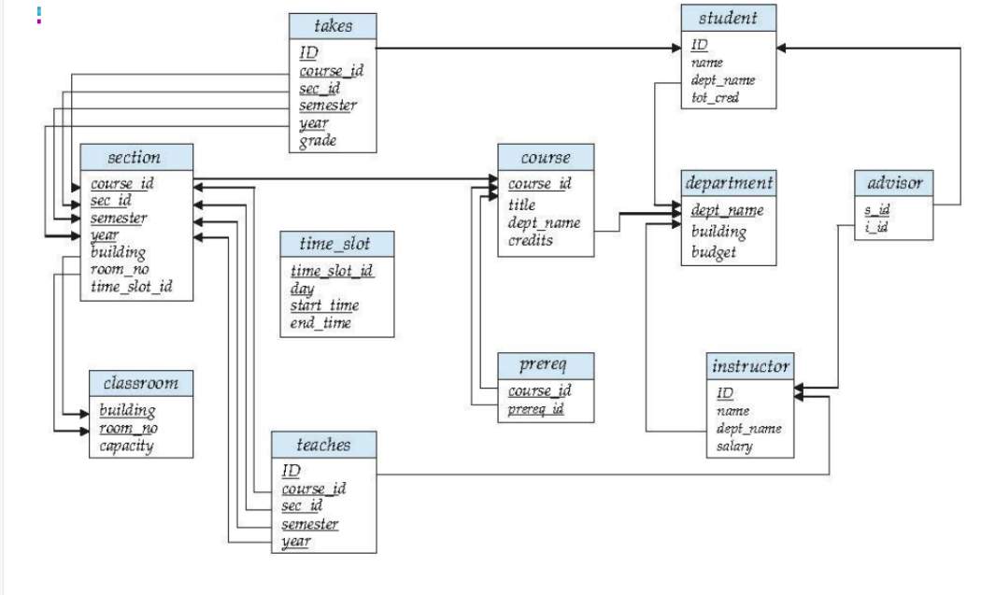

1. **OBJECTIVES:**

After successful implementation of this project we will achieve the following objectives.

* Develop a Comprehensive Database Structure.
* Implement Data Management Functionalities.
* Create a User-Friendly Graphical User Interface (GUI).
* Role-Based Access Control.
* Enable Reporting and Analytics.
* Ensure System Scalability and Performance.
* Provide Data Export/Import Capabilities.
* Implement Error Handling and Logging.
* Provide Documentation and Project Report.

1. **TOOLS & TECHNOLOGIES:**

Throughout the project we will use the following tools and technologies.

1. **XAMPP**: For local development of database-driven applications. It has Apache HTTP Server and MySQL which are need to do this project.
2. **Java:** Programming language for backend logic and GUI development.
3. **Java Swing:** GUI toolkit for building the user interface.
4. **NetBeans IDE:** Integrated development environment for Java development and GUI design.
5. **MySQL:** Relational database management system for storing student data securely.
6. **JDBC (Java Database Connectivity):** API for connecting Java applications to databases.
7. **Apache Maven:** Build automation tool for managing project dependencies and building the project.
8. **Documentation Tools:** LaTeX for preparing project documentation.
9. **Web Browser:** For testing GUI compatibility.
10. **Operating System:** Windows for development and Linux for testing.
11. **CONCLUSION:**

Within due time, I hope to complete the whole project. The selection of Java, Java Swing, NetBeans, MySQL and other tools for successfully build a successful University Student Database project. These technologies enable efficient development, testing, and management, ensuring a user-friendly GUI and secure data management.